ABSTRACT
The early detection of fetal defects plays a pivotal role in determining the health of the newborn, however, the structural malformations, which are collectively responsible for 3% of the pregnancies, frequently go unnoticed especially in the resource-poor areas. Ultrasound screening has been recognized as the prenatal assessment standard by WHO which still many of the low-income countries cannot perform due to the lack of resources and trained personnel needed for first-trimester evaluations. The manual interpretation of ultrasound images encounters serious difficulties caused by the variations in image quality, the subjectivity of operators and the subtlety of some anatomical abnormalities.

Through this research, the authors are proposing an automated fetal anomaly classification system that takes the help of deep learning to overcome these problems. The FUSEP (Fetal Ultrasound Screening in Early Pregnancy) dataset is used to develop a hybrid architecture that mixes ResNet-50 convolutional neural networks with autoencoder models. The ResNet-50 network has been assigned the role of a reliable feature extractor through the utilization of its 50-layer architecture and residual connections allowing it to pick up intricate anatomical patterns in the crown-rump length and nuchal translucency views. An autoencoder, which is trained exclusively on normal fetal anatomy, provides anomaly detection through reconstruction error analysis, learning normative structural features to identify deviations that are indicative of malformations.

The system is made available through a user-friendly web platform that allows specialists to annotate ultrasound images and get similarity scores for diagnostic support. This instrument not only makes expert-level fetal screening available to everyone but also provides automated report generation for clinical teams, researchers, and educational institutions. The combination of advanced computer vision with offline clinical workflows in this way presents a scalable solution to the challenge of improving early pregnancy diagnosis.

Contents
ABSTRACT 1
CHAPTER ONE: INTRODUCTION 3
1.1 Background study 4
1.2 Problem statement 4
1.3 Objectives 5
1.4.1 Primary objective 5
1.4.2 Specific objectives: 5
1.5 Justification 5
1.6 Scope 5
CHAPTER TWO: LITERATURE REVIEW 6
2.1 Introduction 7
2.2 Case studies 7
2.2.1 Object recognition in medicine 7
2.2.2 CNN model architectures 7
2.2.3 ResNet-50 8
2.2.4 Autoencoder 9
2.2.5 Congenital associated anomalies. 10
2.3 Research gap 11
2.4 Summary 11
CHAPTER THREE: METHODOLOGY 12
3.1 Introduction 13
3.2 Development model 13
3.3 Project phases 14
3.3.1 Phase 1: Requirements gathering and planning. 14
3.3.2 Phase 2: Dataset design. 14
3.3.3 Phase 3: Model design 14
3.3.4 Phase 4: User interface and API design 14
3.3.5 Phase 5: Testing and evaluation 15
3.3.6 Phase 6: Documentation and presentation 15
3.3.7 Phase 7: Deployment 15
3.4 Total population 15
3.4.1 Sample size 15
3.4.2 Sample Design 15
CHAPTER FOUR: SYSTEM DESIGN AND ANALYSIS 15
4.1 Requirements 16
4.1.1 Functional requirements 16
4.1.2 Nonfunctional requirements 16
4.2 System design 16
4.2.1 Block diagram 16
4.2.2 Dataset 17
4.2.3 AI models 20
4.2.4 User interface 21
4.2.5 Backend module 22
4.3 System features 23
CHAPTER FIVE: TESTING AND IMPLEMENTATION 23
5.1 Implementation 24
5.2 Testing 24
5.2.1 Integration testing 24
5.2.2 Performance testing 24
CHAPTER SIX: CONCLUSION AND RECOMMENDATION 24
6.1 Conclusion 25
6.2 Recommendation 25
CHAPTER SEVEN: ETHICAL CONSIDERATIONS 25
REFRENCES 26

CHAPTER ONE: INTRODUCTION

1.1 Background study
Fetal anomaly detection during the initial stages of pregnancy is critical in fetal health. Structural malformations occur in 3% of pregnancies which vary widely from manageable conditions to life threatening problems. (Shahrivar & Karami, 2023) In modern medicine, ultrasounds scans are standard for this operation as recognized in the WHO guidelines. (WHO, 2022)
Timely identification is important, especially in the first trimester of the gestation period as this can reduce mortality rates. This, however, is not the case when limitations are considered. Hospital facilities in many low-income countries do not prioritize prenatal ultrasound screening due to financial constraints. Most nations offer one mid-trimester ultrasound scan as part of routine prenatal care to detect problems using biomarkers like fetal biometry and fetal weight estimation to detect anomalies. However, this process is prone to errors and tedious because each screening consists of over 20 images and most sonographers find it challenging to analyze anatomical structures. (Sivasubramanian & University, 2024)
Manual interpretation of ultrasound images is difficult. They come in varying details; noisy, low contrast and some discolored. Sonographers are subjective in their diagnosis leading to missed or incorrect diagnosis. (Matthew & Day, 2024). Subtle anomalies in the brain have a high probability of being overlooked if the image quality is poor or the sonographer is not trained well. Specialized Convolutional models in object recognition like the ResNet-50 can learn rich image features of normal ultrasound scans, hence better suited to detect subtle anatomical anomalies.
The Residual network is a fifty layer deep neural network that uses residual connections to enhance deep feature learning. It provides a powerful feature extractor that has proven useful in the medical field. (Omer & Abbas, 2022). Its residual blocks allow the models to capture the range of features as seen in certain anatomical structures. On top of the ResNet model, an autoencoder will be implemented to process the extracted features. This is a neural network that works on the principle of encoding and decoding. The idea is to extract features of only normal ultrasound images, so the encoder learns normal anatomy structure and to detect anomalies from reconstruction errors in the decoding process in the autoencoder.
This study will feature the development and deployment of a fetal anomaly classifier system, accessible through a web platform where specialists can analyze ultrasound images.

1.2 Problem statement
Despite prenatal ultrasound screening proving a vital tool for screening for fetal anomalies, the technology remains widely inaccessible and poorly established in low resource setting areas like developing third world countries and costly. (MD & MD, 2009). Reliance on sonographers’ expertise is subject to misinterpretation and false diagnosis due to subtle variations in anatomical structure, image quality and sonographer’s subjectivity. There is great need for a system that will help researchers and doctors better diagnose problems early to save time while also availing knowledge to relevant audiences including medical professionals, research groups and students. This will improve the probability of early anomaly detection by reducing mortality rates in children rising from pregnancy complications.

1.3 Objectives

1.4.1 Primary objective
Design a fetal anomaly classification system for analyzing ultrasound images using Resnet for feature extraction and an autoencoders for unsupervised identification of structural anomalies.

1.4.2 Specific objectives:
- To apply normalization techniques based on rule-based logic to obtain appropriate datasets from the original for training models.
- To extract and save normal features of three critical anatomical structures using a ResNet50 neural network which will be used to train an autoencoder.
- To develop an annotation interface to upload and annotate new images for processing.
- To develop a report interface to show a report about inferred ultrasound images from reconstruction errors obtained from the model.
- To evaluate model performance using test data to develop a grading rubric for diagnosis inference.

1.5 Justification
The implementation of the system is like other AI based medical approaches applied by many experts. Specialized convolutional models, like in this case, the residual network reduces errors in object recognition. With the aim of obtaining accuracy scores upwards of 98%, the system will prove its prominence in the ultrasound imaging field.
Ultrasound imaging proves to be costly, time-consuming, and sparse in many regions. The FACS system tends to eliminate these variables by allowing students, researchers, and doctors to access model capabilities just by logging in to a website. Besides the system features that will be offered on deployment, a new set of data will be created, consisting of normal sets of images with normal features. This will be made publicly available for use on other projects by other researchers, students, or medical professionals. Once the project’s objectives are realized, the final product will be a priceless tool in the wide arsenal of medical based AI systems

1.6 Scope
Data type – 2D ultrasound images.
Data range – Ultrasound images from first trimester of the gestational period i.e., 11-14 weeks.
Data volume – A public collection of 4,999 images in CRL and NT views.
Models – Two stage pipeline consisting of Resnet-50 and autoencoder.
Evaluation metrics – accuracy, reconstruction error and confidence score.
Features – Image upload, image annotation and report generation.
Interface – Web app.

CHAPTER TWO: LITERATURE REVIEW

2.1 Introduction
Detection of congenital anomalies has seen quite some rapid developments over the years with the use of deep learning models. Collection of data over the years consisting of high-quality images and development of specialized convolutional models for object detection has boosted the accuracy of diagnosing various illnesses. This chapter will look at existing technologies in the ultrasound field to establish a basis for development and research of this system. It will focus on model comparison. Looking at different implementations of different models and oversight into the medical field of ultrasound imaging to understand what exactly anomalies in anatomical structures are. The study will focus on model architectures, anomaly associated disorders and evaluation performance to build a comprehensive study for the project. The choice in model implementation will be scrutinized to show how the Resnet-encoder pipeline compares to other implementations. We will review transfer learning techniques and applications in ultrasound analysis.

2.2 Case studies

2.2.1 Object recognition in medicine
Object detection is a method of recognizing the class of a specific object in an image by combining image classification and image localization. In 2014, Ross Girshick proposed the RCNN network framework, which combines CNN with regional features to achieve the function of object detection. (Yan, 2018).
A few machine learning techniques have been employed to perform fetal classification tasks. Six fetal ultrasound planes were classified using a random-forest-based technique by (Yaqub M, 2015), (Carneiro, Georgescu, & Good S, 2008) who employed a probabilistic boosting tree to identify and categorize fetal features in a related study. However, a lot of emphasis in recent times has been placed on deep learning-based techniques because of their automatic ability to retrieve features without physical kernels designed by humans, the diversity of data, and the easily available computing power (Divya & Arrun, 2024, p. 2). Additionally, studies utilizing smaller, independent datasets and other popular feature extraction methods have been conducted to categorize fetal planes. Using a testing set of 5678 ultrasound pictures, (Kong P, 2018) employed multiscale dense networks with classification metrics as high as 98% to identify four different fetal anatomies.
A look at different models and their architecture will illustrate need for a lightweight pipeline in image classification tasks.

2.2.2 CNN model architectures
Mainly composed of a classifier and feature extractor. CNN is used to extract feature vectors from various positions in the image, which are then processed by the classifier to classify images. The most common classification method is application of the softmax function which computes probability that each category is compatible with the image. The ResNet50, VGGNet, AlexNet are all constructed based on a similar structure. (Yan, 2018, p. 2). The softmax activation ensures that the predicted probabilities sum up to one for multi-class classification tasks, making it suitable for classification tasks where each input belongs to exactly one class. Adam is the widely used optimizer in deep learning due to its effectiveness in handling sparse gradients and noisy data as it automatically adjusts the learning rate for each parameter, allowing for faster convergence and better optimization of the model’s parameters. (Divya & Arrun, 2024, pp. 6-7).
The table below shows a comparison of performance metrics of different architectures.

Architecture | Number of parameters | Highest accuracy
CNN based
VCG-16 | 138,357,544 | 92.28
ResNet | 44,707,176 | 93.06
Fusion architectures
AlexNet + VCG | 159,979,698 | 95.50

(Divya & Arrun, 2024, pp. 10 - 11)

From the table, fusion architectures prove to be more powerful than CNN based architectures. This shows combining the capabilities of two architectures improves accuracy scoring. However, these models require heavy computational resources, and implementation would require an ideal setup. The residual network on the other hand, is a lightweight CNN with the second highest accuracy in the extract. Even with the least number of tunable parameters it posts a high accuracy score. Integration with a second architecture should result in better accuracy scores evident from the fusion architectures.

2.2.3 ResNet-50
ResNet-50 is a 50-layer residual network in abbreviated form. ResNet-50 is similar to VGG-16.

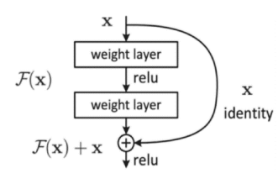

The number of layers in deep learning are usually increased to boost the accuracy of results but unfortunately, experiments show that a large increase in layers leads to emergence of problem in training and testing process called vanishing gradient which leads to wrong results. (Omer & Abbas, 2022, p. 3) The vanishing gradient problem is when the gradients – numbers used to update weights, become very small during backpropagation. This happens when activation functions refactor outputs into small ranges. This means each layer gets gradients that tend to zero and the layer stops learning since as weights barely update. The network becomes stuck or learns very slowly.
Resnet solves the vanishing gradient problem by using ReLU activation function and residual skip connections. ReLU does not refactor gradients into small ranges i.e., derivative is 0 or 1. Resnet's identity mapping allows the model to skip a convolutional neural network (CNN) weight layer if the current layer is not required i.e., derivative is 0. This helps to prevent the problem of overfitting the training set. (Omer & Abbas, 2022). Resnt50 is an ideal model in image classification tasks due to its architecture and mechanism. In this project, the network load is reduced further by removing the final classification layer to obtain an identity matrix as a feature vector.

2.2.4 Autoencoder
A simple neural network that works on principles of encoding and decoding. It consists of three major components, encoder, vector embedding and decoder.

2.2.4.1 Encoder
A series of neural networks – the input part of the network that compresses input data into a vector embedding also called a bottleneck. Maps the input X to a compressed representation Z.
Z = f encoder(X)

2.2.4.2 Vector embedding, Z
Embedding vector that captures the input data features. It is much smaller than the input forcing the model to learn only essential information.

2.2.4.3 Decoder
Final series of neural networks - This component reconstructs input data from the vector embedding attempting to generate output X’ that is as close as possible to the input X. This is done by expanding the vector embedding to match input dimensions.
X’ = f decoder(Z)

2.2.4.4 How it works
Input data. The autoencoder receives input such as a 28x28 pixel image with 784 dimensions when flattened.
Encoding. Input is passed through convolutional layers with ReLU activation functions to convert it to a low dimensional vector embedding.
Decoding. The decoder passes that embedding through layers to reconstruct the input.
Loss function. Model is trained to minimize difference between input and the reconstructed output by implementing a common loss technique, mean squared error.
Training. During backpropagation and using an optimizer, e.g., Adam , the weights of the encoder and decoder are adjusted to minimize reconstruction loss.

2.2.5 Congenital associated anomalies.
Diagnosing fetal based anomalies are based on many factors like anatomical structure under view, biometric measurements, and the type of view present in the image. The study reveals a comprehensive list of common prenatal associated diseases tied to certain anatomical structures and their respective view.
CRL
Anatomical structure | Common anomalies or disease
Head | Macrocephaly – Perlman syndrome
Rhombencephalon | Posterior fossa cysts.
Nuchal Translucency (NTAPS) | Elevated NT - Down syndrome
Abdomen | Omphalocele, gastroschisis
Nasal bone | Hypoplastic nasal bone – Trisomy 21

(Wiley, 2023)
NT
Anatomical structure | Common anomalies or disease
MX, MDS, MLS – Maxilla and mandible | Facial cleft - Hypoplasia
Head | Macrocephaly or microcephaly – genetic or chromosomal disorders
Thorax | Diaphragmatic hernia - rare
Diencephalon | Holoprosencephaly – rare though possible
Nuchal Translucency NT | Elevated NT, congenital heart disease, Noonan syndrome, miscarriage risk

(Fetal Medicine, 2025) (Wiley, 2023) (Nih gov, 2020)

2.3 Research gap
Following the progressive use and application of deep learning models, subtle gaps exist for potentially advanced research and application in the field of ultrasound image classification. The following gaps exist currently; -
- Few systems have explainability features for AI models which would prove particularly useful in clinical use. (al, n.d.)
- Excessive cost in expertise analysis by senior sonographers and big institutions.
- Few studies focus on 2D ultrasound image data, mostly prioritizing 3D.

2.4 Summary
The study shows deep learning features especially specialized models like the Resnet have largely contributed to profound medical advances in ultrasound analysis. This has been achieved through improving accuracy and reducing human error. Explainability techniques are the next step in advancing an established classification model. Introducing this feature to a model allows clinician to see where the model is looking to classify an image. However, these techniques are not normally applied in anomaly classification presenting an opportunity for research expansion. The research confirms that CNN based implementation tailored with fusion approaches are promising technologies. Yet, gaps remain which necessitate advancements in research and development of artificial intelligence-based health systems.

CHAPTER THREE: METHODOLOGY

3.1 Introduction
This chapter presents the methodology employed to design, develop, and evaluate the proposed deep learning system to identify abnormal fetal ultrasound images. By assisting health care professionals with the diagnosis of fetal anomalies, this system aims to improve diagnostic accuracy and performance through less subjective interpretation and more objective assessments. With a methodology that combines agile development and deep learning models, this project presents a structured approach to developing a precise system.
Medical image analysis is complicated enough, consequently, an iterative and incremental approach was elected for this project. An iterative and incremental approach facilitates a frequent testing and updating process which increases assurance that the final product will meet practical and technical requirements. In addition, if the project were to use agile methodology to develop the system as a deep learning model, agile would minimize risk by breaking the implementation down into short sprints which provide opportunities design, testing and evaluation phases even during mid-developmental stages.
First step is requirement gathering and a literature review to learn about existing systems and the medical problems, then collection and preparation of data. This includes processing the ultrasound images to remove noise, and labeling and organizing the ultrasound images. Next, the phase of model design and training. The ResNet-50 model is trained and fine-tuned to classify anomalies using pretrained weights from ImageNet. Many rounds of testing and evaluation will follow to determine accuracy, errors, and other metrics.
Together with the development of the model, the user interface of the system will be designed to allow medical professionals to upload images and view results in an easy and straightforward way. The backend model should connect to the front end seamlessly to provide an interaction between the two components. Ethical considerations at each stage include user data privacy and definitive disclaimers regarding use of AI in medicine.
Progress is monitored using tools like Gantt Project, ensuring that deadlines for milestones including MVP and final testing are met. The use of technologies with recommended features and usability such as Python, Pytorch, and lightweight web frameworks will allow for flexibility and scalability as project development phases progress.
In summary, the selected methodology is favorable in developing of deep learning models and the practical application of a usable and reliable AI system in a healthcare environment. Based on this methodology approach, the project can provide a system that is both robust and medically useful.

3.2 Development model
Agile model is the best fit for this project due to its iterative design approach allowing the major component of the project, the deep learning models, are fine tuned to achieve a high accuracy score for proper diagnosis.
The system features dynamic integrations of different modules which should be integrated with care to ensure the system functions properly. The agile model is flexible enough to ensure any arising issues can be solved at any stage of the project.
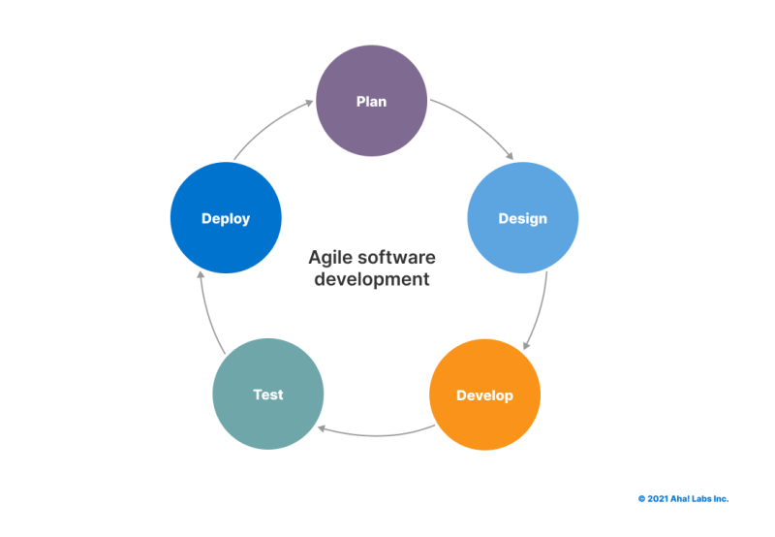

3.3 Project phases
The project is broken down into seven simple phases which will be further broken down into weekly and monthly deliverables. The expected duration for each phase is indicated to establish a good timeline.

3.3.1 Phase 1: Requirements gathering and planning.
Tasks: Define functional and non-functional requirements, identify stakeholders, gather user expectations, and determine dataset normalization logic.
Duration: 2 weeks

3.3.2 Phase 2: Dataset design.
Tasks: Dataset normalization of original dataset.
Duration: 1 week

3.3.3 Phase 3: Model design
Task: Design model pipeline, model training and validation and hyperparameter tuning.
Duration: 2 weeks

3.3.4 Phase 4: User interface and API design
Task: Develop a simple website to facilitate image upload and report generation and connect model via an API to the user interface.
Duration: 2 weeks

3.3.5 Phase 5: Testing and evaluation
Task: System evaluation and testing using metrics like accuracy scores and errors, model parameter refining and small-scale user testing.
Duration: 1 week

3.3.6 Phase 6: Documentation and presentation
Task: Document system architecture, methodology, testing results and feedback then prepare a final report for final project presentation.
Duration: 2 weeks

3.3.7 Phase 7: Deployment
Task: Deploy system locally first to offer a demo for users to use the system.
Duration: 1 day.

3.4 Total population
This project is aimed at hospitals, research institutions and private clinicians.

3.4.1 Sample size
The sample size for this project will be determined through a combination of convenience sampling and stratified sampling techniques.

3.4.2 Sample Design
The sample can be divided into groups according to geographic locations like continent based, and demographic characteristics inclusive of age. The training sample may vary according to the demographic and geographic variables like for this instance; the dataset is sourced from Asian hospitals.

CHAPTER FOUR: SYSTEM DESIGN AND ANALYSIS

4.1 Requirements

4.1.1 Functional requirements
Image upload: The system shall accept ultrasound images in standard crown lump length view or nuchal translucency view, all either in png or jpeg format.
Annotation interface: The system shall provide a tool to draw a bounding box to crop an image.
Image classification: The system shall process annotated images through Resnet50 feature extraction and autoencoder models to generate a reconstruction error which will be the measure of the system.
Reporting: The system shall display classification results, confidence scores, processed images and provide a diagnosis.

4.1.2 Nonfunctional requirements
Scalability: The architecture shall support horizontal scaling to accommodate growing user bases and handle storage expansion up to 1TB of medical imaging data annually.
Security: The system shall encrypt all data transmissions through HTTP/HTTPS Protocol.
Usability: The interface shall be intuitive for users with basic computer literacy.
Maintainability: The source code shall follow industry-standard conventions, maintain good architecture for easy updates and include documentation.

4.2 System design
The system will be composed of four major modules. The components form the standard representation of a minimal viable product that allow continued development and testing of the system. These are the dataset, AI module, a user interface, and a backend API server component. A detailed overview of each module is discussed below to illustrate the system architecture and integration altogether.

4.2.1 Block diagram
The flowchart below represents the modules and how they interact with each other.
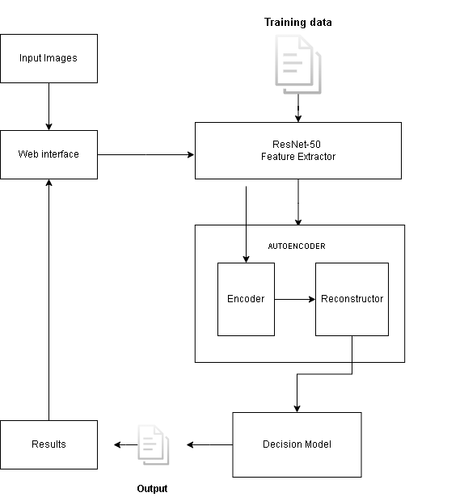

4.2.2 Dataset
This module features a collection of fetal ultrasound images and their labels. This data has been sourced from a public research domain, Kaggle. It contains about five thousand images obtained from three different hospitals. Labels in the dataset are presented in Json format separated into train and test sets. The labels are grouped into three parts, image information, annotations, and categories. Unlike most datasets, this one does not have normal labeling of images, meaning an unsupervised model will work best with this dataset. The annotations in the Json files map the bounding box annotation to its corresponding anatomical feature in the image defined in image information, box area and the category which tells the outlined structure. The image below shows a sample image from the dataset, in nuchal translucency view.
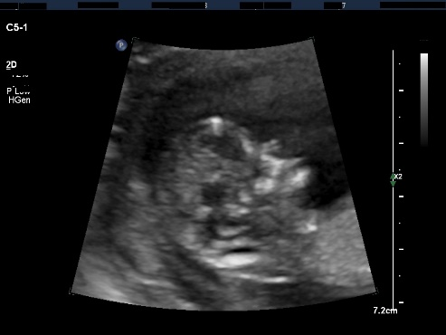

4.2.2.1 Image information
Defines image properties and image dimensions.
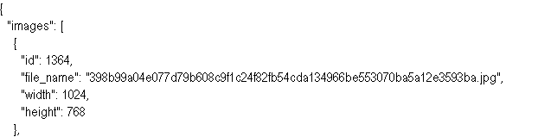

4.2.2.2 Annotations
Defines bounding box annotations for a single image and is linked by image id, like the one above.
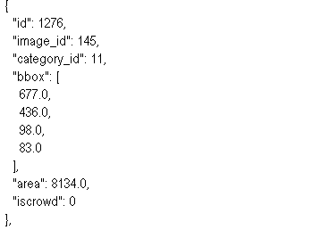
The “bbox” annotations contain four-pixel coordinate values defining a rectangular region on the image where a specific anatomical structure is, from a total of fourteen have been defined.
“bbox”:[x,y,width,height, height] , this means x and y show image location, where the bounding box is located while width and height show image dimensions.

4.2.2.3 Categories
Fourteen anatomical structures visible in a sample ultrasound image respective to the view are mapped to a unique identifier ranging from one to fourteen.
The tables below show the specific structures and their mappings to their identifiers in the labels, for both crown lump length and nuchal translucency views.

Crown lump length view

Category ID | Structure | Description
1 | MX | Maxilla
2 | MDS | Mandible
3 | MLS | Mandible
4 | LV | Lateral ventricle
5 | H | Fetal head
6 | G | Gestation sac
7 | C | Thorax
8 | AB | Abdomen
9 | B | Body (biparietal diameter area)
10 | RBP | Rhombencephalon
11 | DP | Diencephalon
12 | NTAPS | Nasal Tip and Pre-nasal Skin
13 | NB | Nasal bone

Nuchal translucency view

Category ID | Name | Description
1 | MX | Maxilla
2 | MDS | Mandible
3 | MLS | Mandible
4 | LV | Lateral ventricle
5 | H | Head
6 | C | Thorax
7 | AB | Abdomen
8 | RBP | Rhombencephalon
9 | DP | Diencephalon
10 | NT | Nuchal Translucency
11 | NTAPS | Nasal Tip and Pre-nasal Skin
12 | NB | Nasal bone

4.2.2.4 Data normalization
A sample image contains a lot of unnecessary information such as the labels on the image that represent information on the scan results or dark outer regions where no fetal anatomical structure is present. It would be unconventional to train a model on these unnecessary features hence the dataset needs to be sorted. Rule based logic implementation and loops split data into organized groups for normalized feature extraction. For example, from hospital one dataset, all labels of category 5 corresponding to the fetal head in crown lump length view in the training set are mapped to corresponding images so both the images and labels are extracted and saved to a new dataset called normal heads. Features from feature extraction using the ResNet50 model of these normalized datasets reveal patterns when principal component analysis (PCA) is performed. These features are in 2048-dimension vector format. This is achieved by removing the final classification layer in the residual network, so the last layer is an identity matrix layer that gives out 2048-d vectors as outputs. PCA is mathematical function used to reduce the number of features while keeping as much variance as possible. It helps visualize the data in 2D while reducing redundant information. The figure below shows principal component analysis of a normalized fetal head dataset containing 740 images.

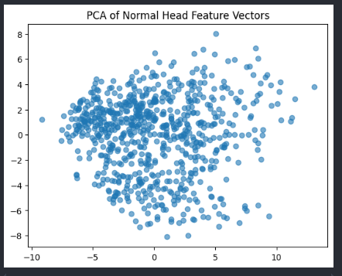

Each dot represents a normal fetal head vector of each image in the set in 2D. Most dots cluster around the center showing the heads share similar features. Those that are scattered outwards represent variations in head shape, orientation, and ultrasound angle.
Since the structures are many, only a maximum of three structures will be used to create three sets of normalized datasets. They will include major anatomical structures key for fetal development.

4.2.3 AI models
The system will feature designing a two-stage pipeline network consisting of two specialized neural networks. These are the Resnet-50 and an autoencoder. The residual networks can be used as a feature extractor. These features in vector form can then be saved and used to train an autoencoder to learn only normal features. During inference, new images features will be compared to the normal features and the decoding process will give a similarity score.

4.2.3.1 ResNet-50
A simple illustration of how features are extracted using the specialized deep neural network.

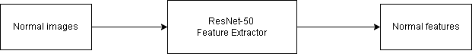

4.2.3.2 Autoencoder
The figure below shows simple workflow of an autoencoder.
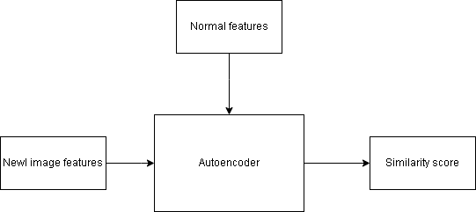

4.2.4 User interface
The user interface allows users to interact with the models and analyze new ultrasound images. A compact and simple interface built for web platforms. The interface features an annotation tab to crop a specific anatomical structure in an image which will be the input of the model. The output is displayed in a result tab showing a detailed report and diagnosis.
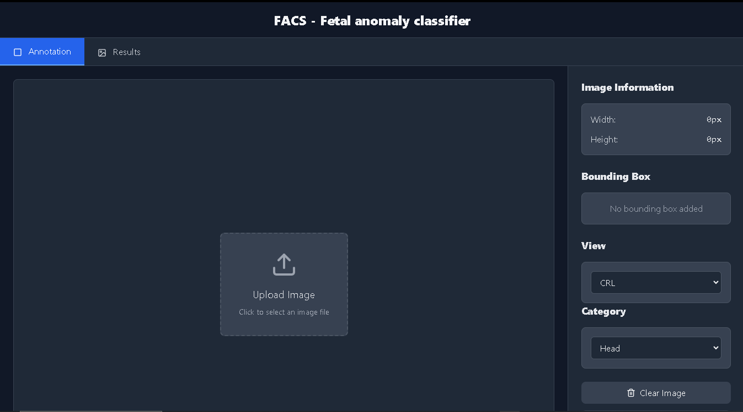
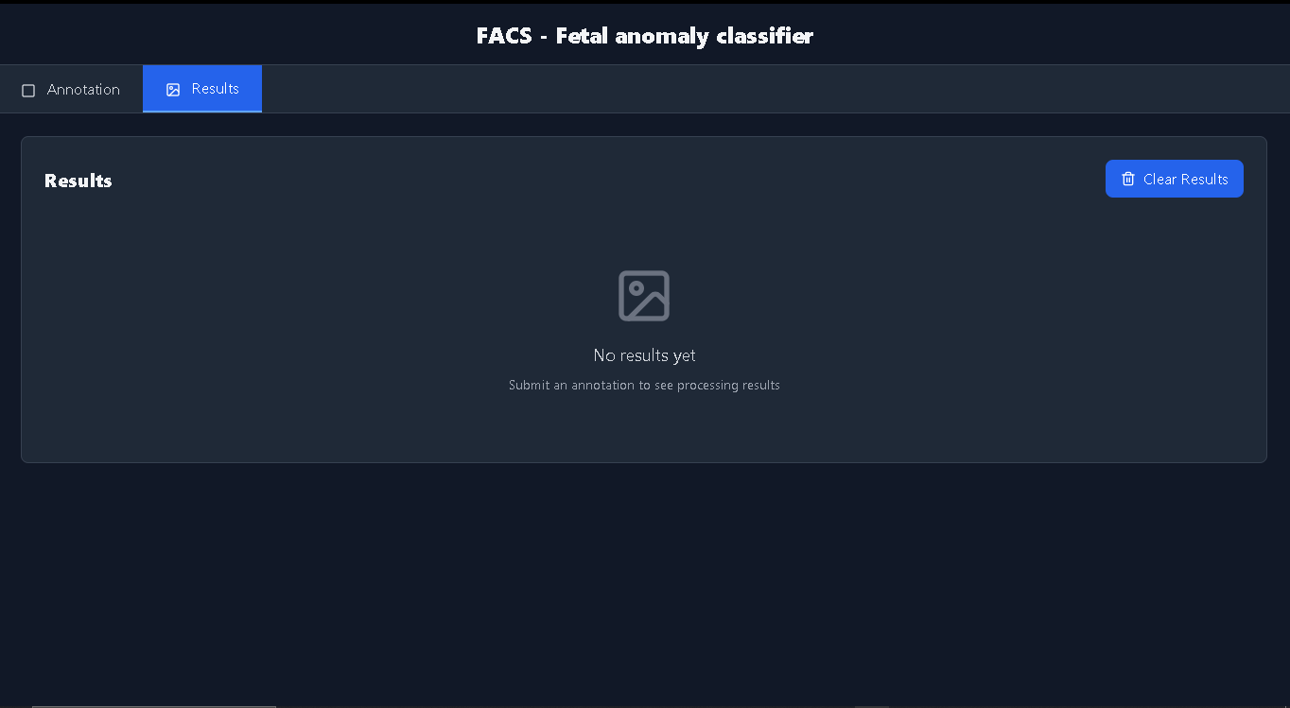

4.2.5 Backend module
The backend module serves as an application programming interface to facilitate communication between the interface and model. Flask library in python provides an efficient mechanism for connecting models and web platforms which is a conventional approach in modern applications.
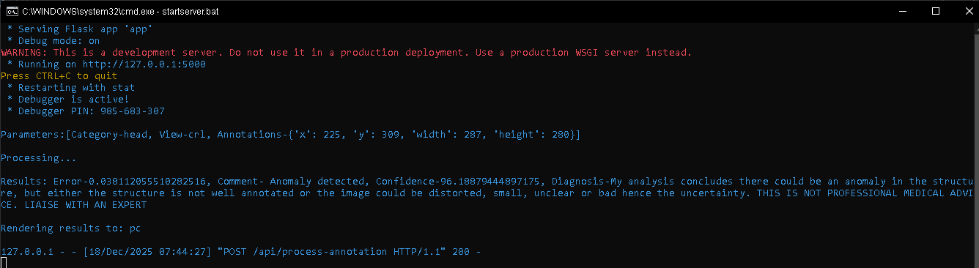

4.3 System features
Integration of the four components discussed above allows key features to be distinguished. These include: -
1.Image upload functionality.
2. Image annotation.
3. Anomaly detection.
4. Diagnosis generation.

CHAPTER FIVE: TESTING AND IMPLEMENTATION

5.1 Implementation
The Fetal anomaly classification system was developed using the React framework and python as the backend. The development environment was established using Cuda Text which facilitated code writing, debugging and testing.

5.2 Testing

5.2.1 Integration testing
The front-end app is connected to the model via a flask REST API endpoint called ‘process annotation’ which receives arguments from the web app and feed a model for prediction. The data flow works seamlessly both locally and publicly. Data is securely sent over via POST.
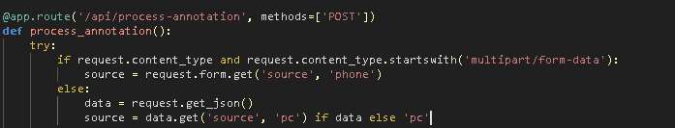

5.2.2 Performance testing
Tested the API endpoint provided by flask that handled data transfer effectively. The local API endpoint reports a latency of 812ms, while a public endpoint exposed via ngrok reports latency of up to 35s. This however varies heavily with internet speed and device capabilities.
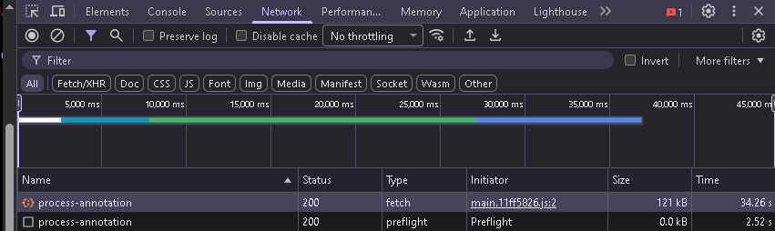
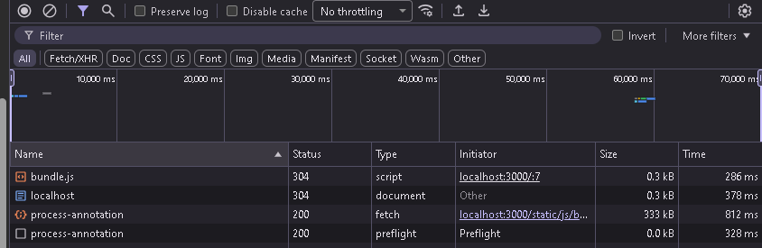

CHAPTER SIX: CONCLUSION AND RECOMMENDATION

6.1 Conclusion
An artificial intelligence-based fetal anomaly detection system is demonstrated through this research paper as a means of effectively and particularly early prenatal screening in resource-limited areas. The linking of ResNet-50 and autoencoder with the system ensures the first-trimester ultrasound images are uniformly and objectively analyzed with the manual interpretation having the subjectivity reduced. Besides that, the web-based platform further allows for image upload, annotation, automated analysis, and report generation within one interface.
With the FUSEP dataset being the training ground for the models, they were able to learn normal fetal anatomical features and abnormality-causing deviations. Automated reporting not only enhances clinical documentation but also helps the research and audit processes. In a nutshell, the system has not only challenged the pregnant women who seek to get such diagnostic support at a cheaper and more convenient place but also proved the outstanding benefits of deep learning in prenatal healthcare and education as well as clinical decision support.

6.2 Recommendation
The performance of the diagnosis would be improved if the datasets were enlarged to include different populations and a broader range of abnormalities, in addition to the incorporation of more ultrasound views.
The future work should focus on the expansion of the training sets of images where comprehensive and well curated datasets are developed. This will allow advanced data interpretation in different continents, attitudes, countries and regions.

CHAPTER SEVEN: ETHICAL CONSIDERATIONS
This study ensures that all components and development stages of the project follow ethical guidelines especially with the use of data and AI in medicine. Artificial intelligence is undoubtedly important in classification tasks as seen in commercialized applications. It is important to note that the model may give high accuracy scores due to constraints of overfitting or underfitting to a particular data set. Many factors are considered when implementing such a system. For example, hyperparameter tuning stages in model testing and evaluation affects the weights of a neural network which has a high probability of changing the output.
Model output may show high accuracy scores when predicting congenital anomalies in an ultrasound image, however, this should not be taken as professional medical advice. The criticality of diagnosing fetal anomalies leaves a small margin of error for uninformed interpretation of results from an AI system.
A rubric for anomaly scoring will be implemented to map model output to the best possible diagnosis after testing and evaluation to ensure a final credible system. However, this will include markers for letting the user know of the risk involved of sorely relying on artificial intelligence for diagnosing illnesses.
The system will employ certain ethical policies to ensure users are well informed and data is safe. They include: -
- No user uploads will be saved at any processing stage.
- Diagnosis will be based on a simple rubric constructed from model output analysis but will always be shown with a disclaimer on AI usage.
- The system will majorly be designed for use by researchers and experts in the field of ultrasound.
- General diagnosis provision. This means model will give a shallow description on diagnosis necessitating presence of an expert sonographer to give a complete and informed diagnosis based on other metrics like errors and accuracy scores.

These guidelines redefine the design methodology slightly to accommodate ethics and safe AI use in an important medical field.

REFRENCES
(2020). Retrieved from Nih gov: https://pmc.ncbi.nlm.nih.gov/articles/PMC3681077/?utm_source=chatgpt.com
(2023, June 1). Retrieved from Wiley: https://obgyn.onlinelibrary.wiley.com/doi/full/10.1002/pd.6390
(2025, May 25). Retrieved from Fetal Medicine: https://fetalmedicine.com/nuchal-scan
al, S. e. (n.d.). Retrieved from www.nature.com: https://www.nature.com/articles/s41598-025-04631-y
Carneiro, G., Georgescu, B., & Good S, C. D. (2008). Detection and measurement of fetal anatomies from ultrasound images using a constrained probabilistic boosting tre. IEEE Trans Med Imaging, 1342-1355.
Divya, S., & Arrun, S. (2024). Efficient Feature Extraction Using Light-Weight CNN Attention-Based Deep Learnin Architectures. arXiv:2410.17396v1 [eess.IV], 6-7.
Kong P, W. J. (2018). Automatic and efficient standard plane recognition in fetal ultrasound images via multi-scale dense networks. Data Driven Treat Response Assess Preterm Perinatal Paediatr Image Anal. 2018, 23-32.
Matthew, J., & Day, T. G. (2024). Artificial Intelligence to Assist in the Screening Fetal Anomaly Ultrasound. Scan (PROMETHEUS): A Randomised Controlled Trial, 3-5.
MD, R. D., & MD, W. M. (2009, Auust 01). Retrieved from Onlinelibrary: https://doi.org/10.7863/jum.2009.28.8.1067
Omer, Z. T., & Abbas, A. H. (2022). Image anomalies detection using transfer learning of ResNet-50. Indonesian Journal of Electrical Engineering and Computer Science, 2-3.
Shahrivar, R., & Karami, E. (2023). Enhancing Fetal Anomaly Detection in Ultrasonography. biomimetics, 1.
Sivasubramanian, A., & University, P. M. (2024). Efficient Feature Extraction Using Light-Weight CNN Attention-Basd Deep Learning Architectures. arXiv:2410.17396v1 [eess.IV], 1-2.
WHO. (2022). WHO antenatal care recommendations for a positive pregnancy experience.
Yan, H. (2018). Computer Vision Applied in Medical Technology: The. dvances in Computer Science Research, volume 86, 2-3.
Yaqub M, K. (2015). Guided random forests for identification of key fetal anatomy and image categorization in ultrasound scans. Med Image Comput Comput Assist Interv, 18-26.

- PROJECT SCHEDULE TIME
Phase | Activity | Task | Duration | Start | End
1 | Requirement gathering  And planning | Define requirements, stakeholders, expectations, and normalization methods. | 2 weeks | Week 1 | Week 2
2 | Dataset normalization | Normalize original dataset. | 1 week | Week 3 | Week 3
3 | Model design and training | Design model pipeline, train & validate. | 2 weeks | Week 4 | Week 5
4 | UI & API design | Builds minimal interface & integrate with API to model. | 2 weeks | Week 6 | Week 7
5 | Testing & evaluation | Evaluate accuracy and error metrics from model and refine hyperparameters. | 1 week | Week 8 | Week 8
6 | Documentation | Document system & compile comprehensive report for presentation | 2 weeks | Week 9 | Week 10
7 | Deployment | Deploy system locally. | 1 day | Week 11 | Week 11

